Practical 10A : File Permissions

Practice 1: Creating Users

Scenario: You need to set up several users and enable them to share a folder with read and write permissions.

Deliverable: A system with users sales1, sales2, sales3 belonging to the Sales Dept. They can access a shared directory called /home/Salesdoc. A user mktg should not have access.

Instructions:

- Login to the RedHat Client VM as a ordinary account (student or rhel6).

- Open a Terminal window on the RedHat Client VM.

- Connect to RedHat Server as student and escalate your privileges to root with su – command (below example, login to RedHat client as student):

[student@client ~]$ ssh server
Password: redhat
[student@server ~]# su -
Password: redhat
[root@server ~]#

In order for ssh server to work, you must edit the /etc/hosts file to include a line that maps the server IP address (eg. 10.0.0.3) to server.

Note: if the ssh command does not work, exit RedHat Client VM and log in to the Red Hat Server VM directly as root to continue with the practice.

- Use useradd command or other means to add accounts for the following four users to your system: sales1, sales2, sales3, mktg. For the password, use redhat

[root@server ~]# useradd sales1
[root@server ~]# passwd sales1
Password: redhat

- Create a group called groupsales and add sales1, sales2, sales3 as its members.
How do you verify that the group is created and the members are added inside?

[root@server ~]# groupadd groupsales
[root@server ~]# usermod -a -G groupsales sales1

- Create a shared directory called /home/salesdoc.
Who is the owner and group of this directory?
What is the default permissions?

[root@server ~]# mkdir /home/salesdoc

- Change the group of /home/salesdoc to groupsales.
How to verify the change is successful?

[root@server ~]# chgrp groupsales /home/salesdoc

- Configure the setgid for /home/salesdoc and enable group write permission too.
Verify the configuration is successful.

student@client ~]$ chmod g+ws /home/salesdoc

- Log out of the Client and log in again as sales1. Remote login to the server as sales1 and create a file called sales1.out (with some data) in /home/salesdoc.

sales1@server ~]$ echo “sales1 wrote this” > /home/salesdoc/sales1.out

View the permissions of the file sales1.out
Who is the owner? Who is the group?

- Change to sales2 account. Attempt to read and edit sales1.out

[sales1@server ~]$ su – sales2
Password:
[sales2@server ~]$ cat /home/salesdoc/sales1.out

Were you able to read and edit the file sales1.out?
Create a file called sales2.out in /home/salesdoc.

- Change to user mktg and try to view the file /home/salesdoc/sales1.out
Were you successful?

- Configure such that anyone who is not a member of groupsales should not be able read the files in /home/salesdoc.
Only members of groupsales can read and write files in /home/salesdoc.

Test your system.
Does it work for sub-directories under /home/salesdoc?
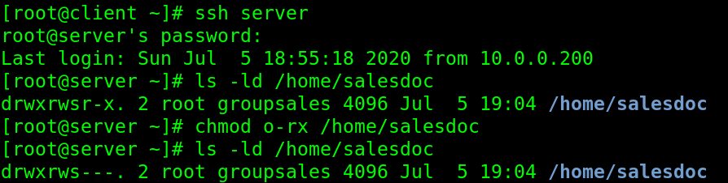
chmod o means you are working with others. After d is _ _ _ (user), then _ _ _ (group) then _ _ _ (others)

- Run below command and snapshot the output into the boxes:

$ ls -ld /home/* | grep salesdoc

$ ls -la /home/salesdoc
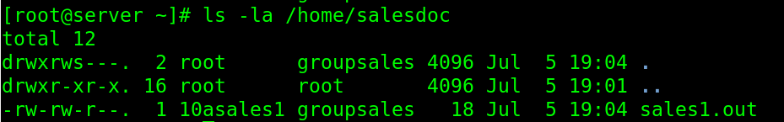

Ask the tutor to check your snapshots as this may be done in the practical test.

- Log out of the Client when completed.

[THE END]

